<http://www.portlincolntimes.com.au/story/1811955/severe-fire-danger-calls-for-more-volunteers/>

# Severe fire danger calls for more volunteers

Oct. 1, 2013, 8 a.m.

* 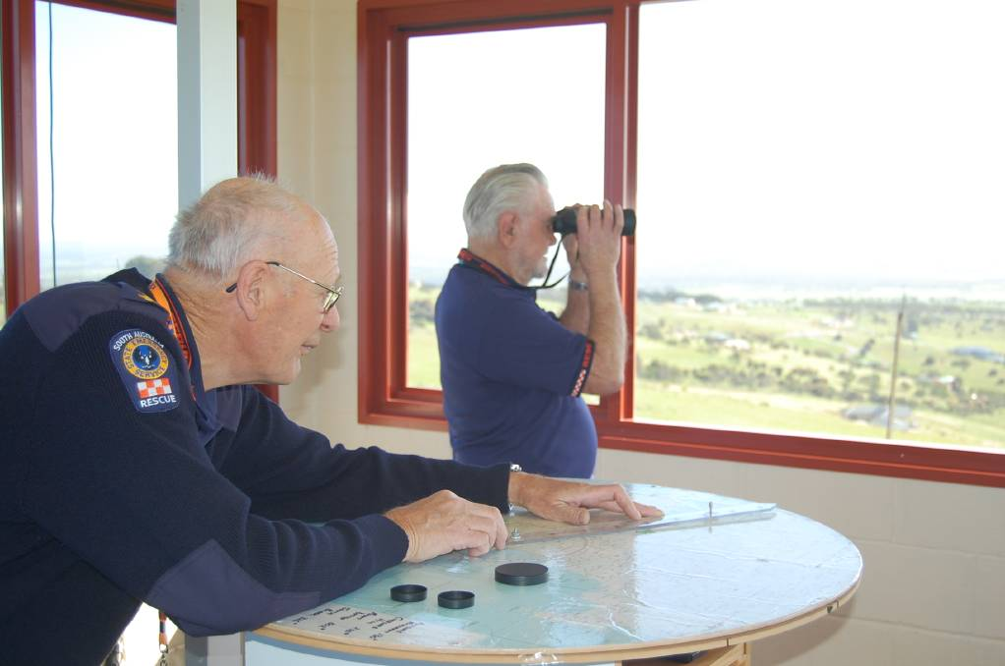

ON THE LOOKOUT: Deputy Unit Manager Ernie Irwin and Observation Tower Manager Bob Boyle look for fire out of the SES tower on Winter's Hill.

WITH the fire danger season starting on November 1 the State Emergency Service West Operations co-ordination unit is preparing for the strong possibility of a very severe fire season.

Last season's fire danger period was extended by six weeks and this seaon's fire period looks set to be just as bad with the CFS looking at bringing the start date of the season forward a few weeks due to the extra growth of crops this season.

"The growth all the way up the peninsula right up through Wudinna right up through to Ceduna is very high," SES deputy unit manager Ernie Irwin said.

This tall growth will increase the risk of fire danger and may result in an extended fire danger season with greater risks of fires.

While the SES does not fight the fires they play the important role of reporting fires to the CFS and are there to help the CFS when they are out fighting a large fire.

The SES provide firefighters with food and water, and putting out roadblocks.

However the SES does not just help with fires, it is also involved with other emergencies such as storm damage, flooding and marine incidents.

With the possibility of a severe fire season Mr Irwin and his colleges are encouraging people to come out and volunteer.

The unit plays a major role in reporting fires and co-ordinating fire fighting activities.

The emergency observation tower, located on Winter's Hill, is manned when the fire risk is severe, extreme or catastrophic.

Anyone interested in volunteering can contact Gordon Hartley on 0429 900 840.

The following entry was found in the Minutes of the Finance Committee meeting of the District Council of Lower Eyre Peninsula on 21st Aug 2009:

-

## Position

DEG: -34.701599 135.826996

DMS: 34º 42' 5.76" S 135º 49' 37.19" E Map: 6028-1-3

UTM: 53 H 6159736mN 575739mE

Altitude: 225.77m